# HOSPITAL MANAGEMENT SYSTEM

The proposed Hospital Management System is an integrated platform that automates and streamlines hospital operations, providing real-time access to patient data, improved resource management, and efficient billing processes. The system will help to streamline hospital operations, improve patient care, and enhance the efficiency and effectiveness of healthcare providers. The system will be hosted in the cloud and will be available from any internet-connected device. It will be designed with a user-friendly interface to facilitate easy adoption by medical staff, administrators, and patients.

The healthcare industry is one of the most critical sectors, responsible for providing essential services to the community, (WHO, 2008). The management of healthcare facilities has become increasingly complex due to the growth in population and the number of patients. The existing healthcare management systems have limitations that hinder their effectiveness in managing patient care, hospital resources, and billing processes. Therefore, the need to develop a new system that can address these limitations and improve hospital operations is essential.

# Problem Diagnosis

The current healthcare management systems have several limitations that hinder their effectiveness in managing hospital operations. These limitations include: Inefficient patient management systems: Existing patient management systems are slow and cumbersome, leading to long waiting times, which results in dissatisfied patients. Manual appointment scheduling: Manual appointment scheduling is time-consuming and prone to errors, leading to missed appointments and unsatisfied patients. Ineffective resource management: Hospitals have to manage a large number of resources, including staff, medical equipment, and medicines. The current management systems do not provide effective resource management, leading to mismanagement and waste. Inefficient billing processes: The current billing processes are time-consuming, error-prone, and often result in delayed payments, which affects hospital revenue.

# Prescription/Justification

To address the limitations of the existing healthcare management systems, we propose the development of a Hospital Management System. The system will provide a comprehensive solution for hospital operations, including patient management, appointment scheduling, resource management, billing and payment, and reporting.

The Hospital Management System will provide several benefits, including: Improved patient care: The system will provide a more efficient and effective patient management system, leading to better patient outcomes and satisfaction. Increased efficiency: The system will automate processes, reduce paperwork, and provide accurate and timely information, improving hospital efficiency. Improved revenue generation: The system will provide accurate and timely billing information, reducing errors and improving revenue collection. Enhanced resource management: The system will provide effective resource management, ensuring staff, equipment, and medicines are available when needed.

# System Requirements

A system requirement consists of hardware and software requirements, (Christensson, 2020). Our system will include the following requirements.

## Functional Requirements

* Patient registration: Patients should be able to sign up with their name, address, medical history, and insurance details.
* Appointment scheduling: Appointments with physicians, nurses, and technicians should be available for patients to book via the system.
* Medical record management: The system needs to let doctors see and change everything from a patient's lab findings to their diagnosis and treatment plan.
* Billing and payment: The system should provide medical personnel access to billing information and enable patients to see and pay their invoices online.

**Non-functional requirements**

* Performance: The system must be able to support a high volume of users at once and respond quickly to their requests.
* Security: The system should be designed to ensure the confidentiality, integrity, and availability of patient data, and should comply with relevant security standards and regulations.
* Scalability: The system should be designed to accommodate future growth and expansion, including the addition of new medical staff, patients, and features.
* Usability: The interface must be intuitive and navigate for both patients and medical staff, and should provide clear and concise instructions and feedback.

# Constraints

* • Compliance with applicable laws and regulations, including as HIPAA and other privacy and security standards, is mandatory for the system.
* Hardware and software limitations: The system must be designed to work with existing hardware and software, and should be scalable to accommodate future upgrades or changes.

## Hardware Requirements

* Laptop (minimum core i3)
* printer
* Flash disk(minimum 2GB)
* Internet

## Software Development Tools

* Windows operating system (minimum windows 7)
* Microsoft office 2013
* Browser (Chrome, Mozilla Firefox and Internet Explorer)
* Visual Studio Code
* MySQL

## Programming languages

* Php
* Laravel
* Html
* Java Script
* CSS, Bootstrap

# Features of the proposed Hospital Management System

1. Patient Management System: The system will allow medical staff to manage patient information, including demographics, medical history, and test results. Access to medical records and appointment scheduling for patients will also be facilitated by the technology.
2. Appointment Scheduling System: Medical professionals will be able to better manage patient visits and other commitments with the help of this appointment scheduling system. Patients will also be able to schedule appointments online and receive notifications.
3. Resource Management System: The system will allow hospital staff to manage hospital resources, including staff, medical equipment, and medicines. The system will track resource availability, usage, and maintenance.
4. Billing and Payment System: The system will automate billing processes and provide accurate and timely billing information to patients and insurance companies. The system will also provide payment options for patients and generate revenue reports for hospital administrators.
5. Reporting System: The system will generate reports on hospital operations, including patient data, staff performance, and financial performance. The system will also provide analytics on hospital operations to help administrators make informed decisions.

# System Design

UML diagrams and data flow diagrams, will help stakeholders and the development team to have a clear understanding of the structure and functionality of the healthcare management system. The system's efficiency, effectiveness, and security, as well as its ability to satisfy the demands of all stakeholders, may all benefit from this.

## UML Diagrams

### Use Case Diagram

This diagram should illustrate the different actors and use cases involved in the healthcare management system, including patients, medical staff, and administrators. It should show how these actors interact with the system to perform various tasks, such as scheduling appointments, managing medical records, and processing payments.

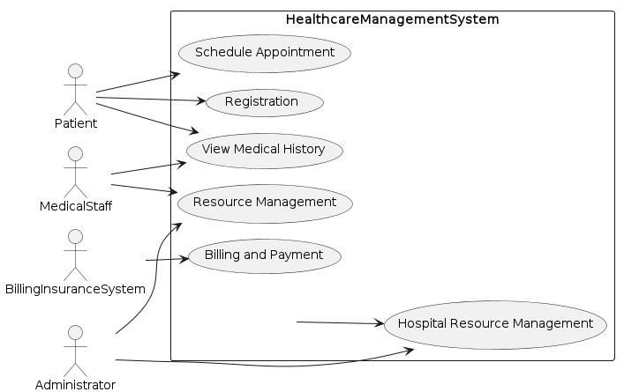

### Class Diagram:

This diagram should illustrate the different classes involved in the healthcare management system, including patients, medical staff, and administrators, as well as any other relevant classes such as appointments, medical records, and billing information. It should show how these classes are related and how they interact with each other to perform different functions within the system.

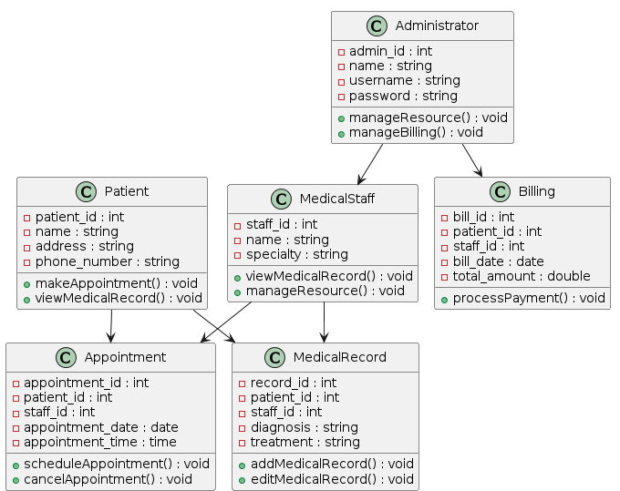

### Sequence Diagram:

This diagram should illustrate the different steps involved in various processes within the healthcare management system, such as scheduling an appointment, updating a medical record, or processing a payment. It should show the different actors and objects involved in each step, as well as any relevant messages or inputs and outputs.

***Scheduling an appointment***

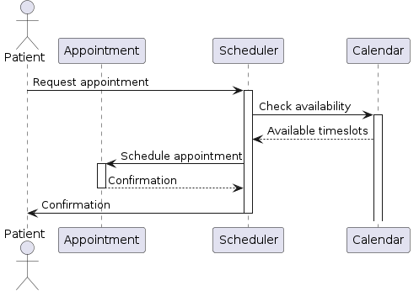

This diagram illustrates the steps involved in scheduling an appointment, with the Patient actor requesting an appointment and the Scheduler checking the availability in the Calendar. The Scheduler then schedules the appointment with the Appointment object and sends a confirmation to both the Patient and the Appointment**.**

***Update Medical Record***

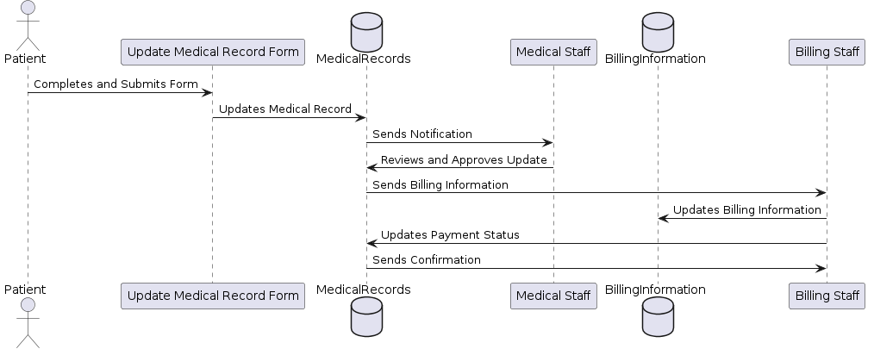

This diagram illustrates Update of Medical Record where patients can input their medical record updates, and medical staff can review and approve them. The updated medical records will then trigger a billing process, where billing staff will update the billing information and payment status accordingly. Finally, the medical records system will send a confirmation to the billing staff.

**Patient registration:**

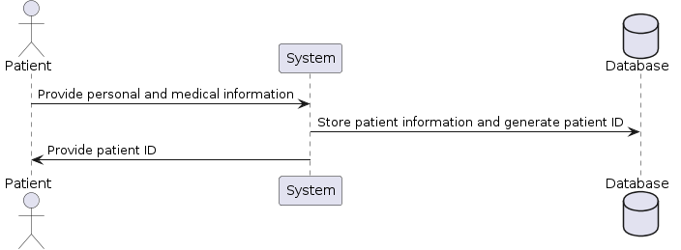

In this sequence diagram, the actor "Patient" interacts with the "System" to register as a patient. The "System" communicates with the "Database" to store the patient information and generate a unique patient ID. Finally, the "System" provides the patient with the generated ID.

**Resource management**

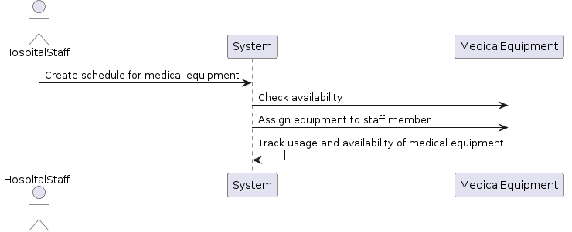

Hospital staff creates a schedule for medical equipment and assigns it to a specific medical staff member for use during the scheduled appointment. The system tracks the availability and usage of medical equipment.

**Patient medical history:**

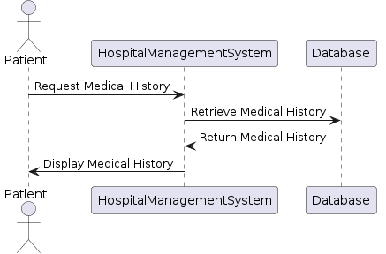

The system stores and retrieves the patient's medical history, including past medical procedures, diagnoses, and medications prescribed.

# Context Diagram

Hospital Management System's context diagram looks like this:

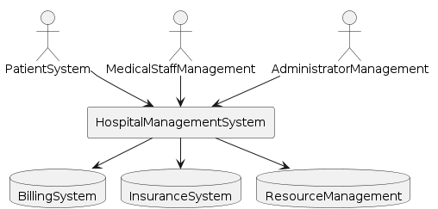

The "Hospital Management System" is the main focus of this flowchart, and it interfaces with three primary actors: "Patient System", "Medical Staff Management", and "Administrator Management". These three actors are connected to the Hospital Management System through lines, indicating the flow of data and communication.

The "Patient System" allows patients to interact with the hospital management system, providing information about their appointments, medical records, and billing. The "Medical Staff Management" system provides hospital staff with access to the hospital management system, allowing them to manage patient records, schedule appointments, and perform other clinical tasks. The "Administrator Management" system allows hospital administrators to manage and monitor the hospital's resources, such as medical equipment and staff scheduling.

The Hospital Management System also interfaces with two external systems: "Billing System" and "Insurance System", which manage billing and insurance information for patients. The "Resource Management" system allows the hospital to track inventory levels and manage supplies and equipment.

This context diagram provides a high-level view of the hospital management system, showing how it interfaces with external systems and primary actors, and manages hospital resources.

# Primary actors

* Patient
* Medical Staff
* Administrator

## Interfaces

* Patient interacts with the system for appointment scheduling, registration, and billing and payment.
* Medical staff interacts with the system for resource management and patient medical history.
* Administrator interacts with the system for managing hospital resources, such as medical equipment and staff scheduling.
* The system interfaces with external systems, such as billing and insurance systems.
* The system manages hospital resources, such as medical equipment and staff scheduling.

# Project Schedule

Scheduling a project is breaking down all of the tasks involved into manageable chunks and then estimating how much time will be needed to complete each individual activity. Several of these tasks are often completed simultaneously. Ian Sommerville(2006). The development of the Hospital Management System will be divided into the following phases;

1. Requirements gathering: This phase will involve gathering requirements from hospital staff, administrators, and patients to ensure the system meets their needs.
2. The system will be designed and developed based on the requirements collected in the previous phase.
3. There will be testing to make sure the system is up to par, and then the system will be deployed to the hospital.
4. Documentation: This phase will involve involves creating and organizing all the necessary project documents and information. This phase ensures that all stakeholders have access to the information they need to successfully execute the project.
5. Ongoing maintenance and support At this last stage, we'll make sure the system keeps running well by providing regular maintenance and assistance.

|  |  |  |  |  |  |  |  |  |
| --- | --- | --- | --- | --- | --- | --- | --- | --- |
| ACTIVITY | TIME (WEEKS) | | | | | | | |
| 2 | 4 | 6 | 10 | 12 | 14 | 16 | 18 |
| Requirements gathering |  |  |  |  |  |  |  |  |
| Design and development |  |  |  |  |  |  |  |  |
| Testing and deployment |  |  |  |  |  |  |  |  |
| Documentation |  |  |  |  |  |  |  |  |
| Maintenance and support |  |  |  |  |  |  |  |  |

# Appendices

## Appendix A: Software Development Life Cycle of Incremental model

In developing the hospital management system, the incremental model of the SDLC, (InterviewBit, 2022)will be followed as below;

1. **Requirement phase:**

Expertise in product analysis is used in this increment of the model to determine the most fundamental needs. In this step, the requirement analysis team works to define the specific features that the system must have. Team members classified the system's features after thoroughly grasping the user demand and preparing a product requirement tools document. In the incremental model of software development life cycle, this requirement step is crucial to the creation of the final product..

1. **Design and Development phase:**

At this point in time, the system's functionality has been effectively designed, and the development process has been completed, according to the incremental model of SDLC. Each time a product update or new feature is added, the incremental model goes through a new round of design and development.

1. **Testing phase:**

Each current function in the system under development and the new functionality are tested during the testing phase of the incremental approach. At this stage, many testing strategies are employed to examine how the various classified functions and the overall system react.

1. **Implementation phase:**

The coding phase of a not-yet-complete system is made possible by the implementation phase of an incremental model. When the system's design and development have been completed and its functioning has been tested in the testing phase, the final coding may begin. When this step is finished, the product's functionality is improved and updated until it reaches the final system product

**REFERENCES**

Christensson, P. (2020, 01 30). System Requirements. Retrieved from TechTerms: https://techterms.com/definition/system_requirements

InterviewBit. (2022, 06 08). InterviewBit. Retrieved from Incremental Model in Software Engineering: https://www.interviewbit.com/blog/incremental-model/

Somarville, I. (2006). Software engineering. 8th edition. Addison-Wesley Publishing Company. Computer science series.

WHO. (2008). ommunity Involvement in Tuberculosis Care and Prevention: Towards Partnerships for Health: Guiding Principles and Recommendations Based on a WHO Review. Retrieved from National Library of Medicine: https://www.ncbi.nlm.nih.gov/books/NBK143699/